AI-Based Interview Question Generator
Project Title: | AI Interview Question Generator
Project ID: | P_112

EXHIBIT-01: Home Dashboard & Enterprise Branding
Main landing interface featuring persistent AI Interview Pro branding, live system status, feature overview, and rapid navigation.
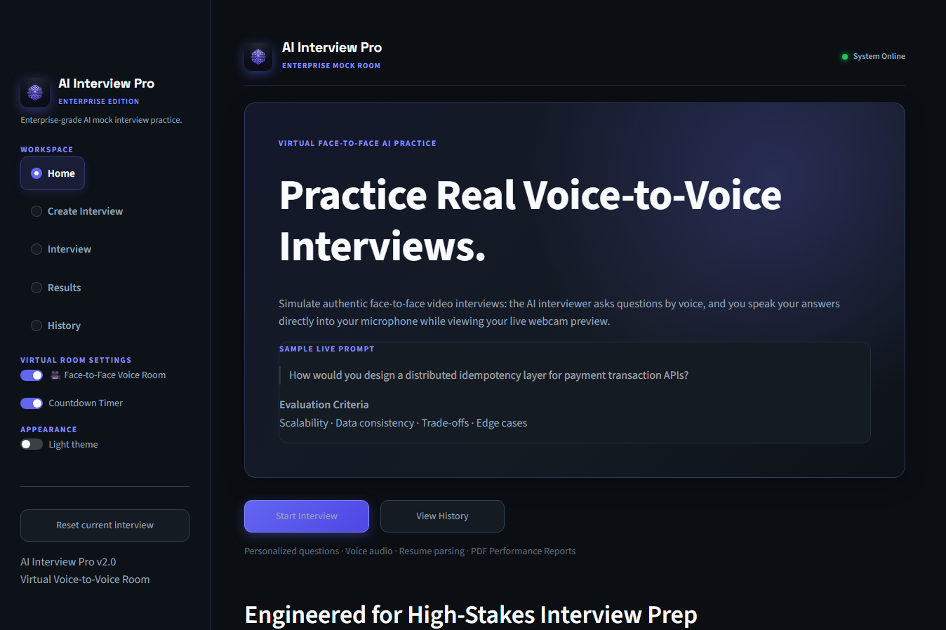

EXHIBIT-02: Interview Creation Workspace & Customization
Session configuration studio allowing candidates to select roles, target companies, technical skills, and upload resume files.
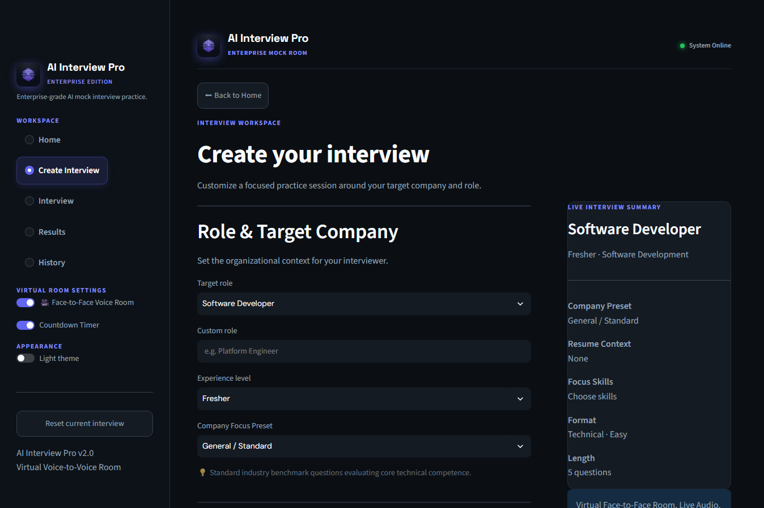
Key Features Demonstrated in this View:
- Company-Specific Presets: Fine-tuned configurations for Google, Amazon Leadership Principles, Microsoft, and Startups.
- Resume Parser: Direct upload support for PDF/TXT CVs, automatically extracting project context.
- Configurable Parameters: Experience level, technical domains, question types, and challenge depth.
- Live Interview Summary: Real-time dynamic card previewing session metadata.

EXHIBIT-03: Virtual Face-to-Face Voice-to-Voice Room
Live video call layout with dual tiles simulating an actual remote video interview call.
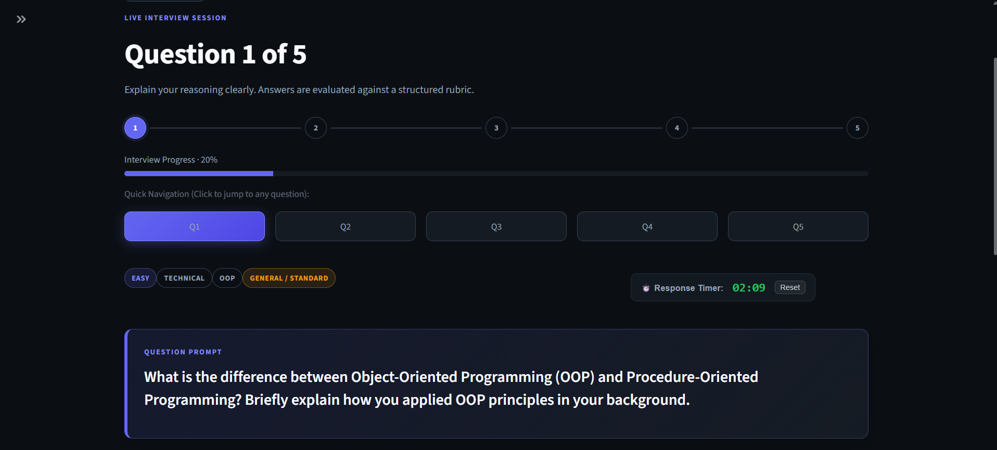
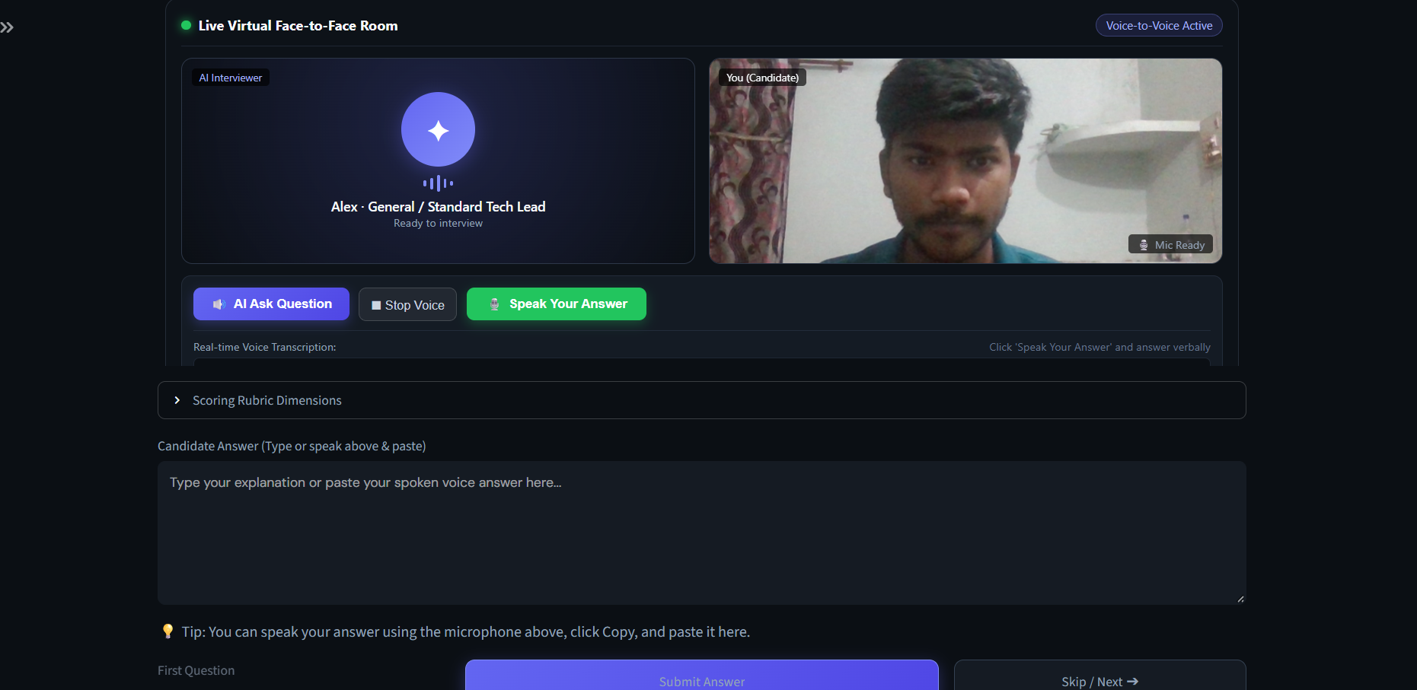
Key Features Demonstrated in this View:
- AI Interviewer Tile: Virtual interviewer persona ('Alex · Tech Lead') with real-time soundwave audio visualizer.
- Candidate Webcam Tile: Live mirror video feed displaying candidate body language and facial presence.
- AI Speech (TTS): 'AI Ask Question' button reading technical questions aloud in conversational natural English.
- Speech Recognition (STT): 'Speak Your Answer' microphone button converting verbal responses into real-time text.
- Response Timer: Active countdown timer (03:00) with color-coded warning alerts.

EXHIBIT-04: AI Rubric Evaluation & Adaptive Follow-up
Structured evaluation engine scoring responses against rubrics and generating adaptive follow-up cross-questions.
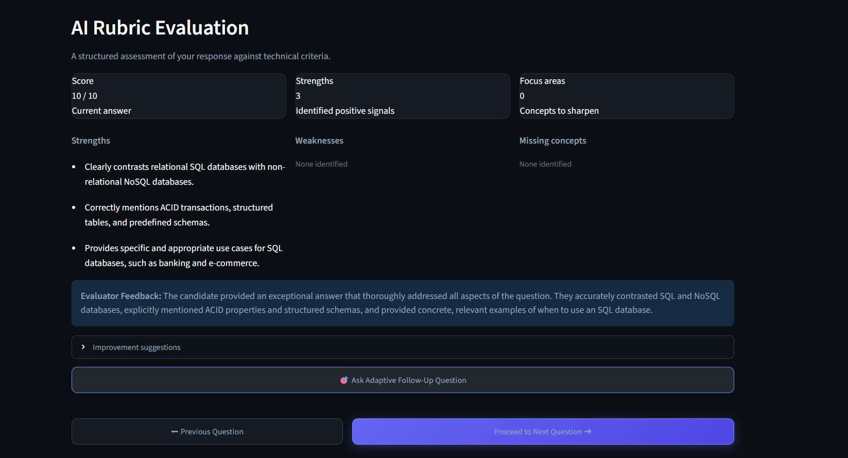
Key Features Demonstrated in this View:
- Multi-Dimensional Scoring: Instant evaluation score (e.g. 8.5 / 10) across concept, accuracy, example, and depth.
- Strengths & Missing Concepts: Actionable diagnostic feedback highlighting technical gaps.
- Adaptive Cross-Questioning: 'Ask Adaptive Follow-Up Question' button challenging candidate depth.
- Persistent Answer Storage: Candidate response and follow-up answer saved seamlessly.

EXHIBIT-05: Performance Analytics Dashboard & Multi-Format Exports
Comprehensive debrief screen showing competency scores, charts, question reviews, and download actions.
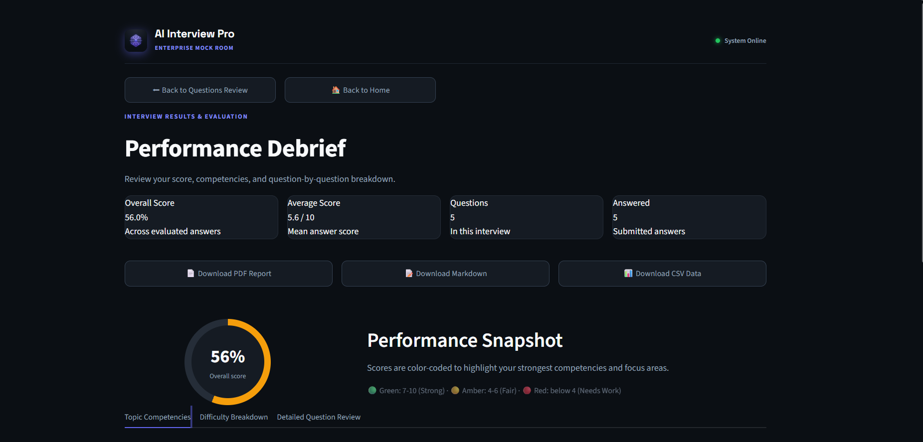
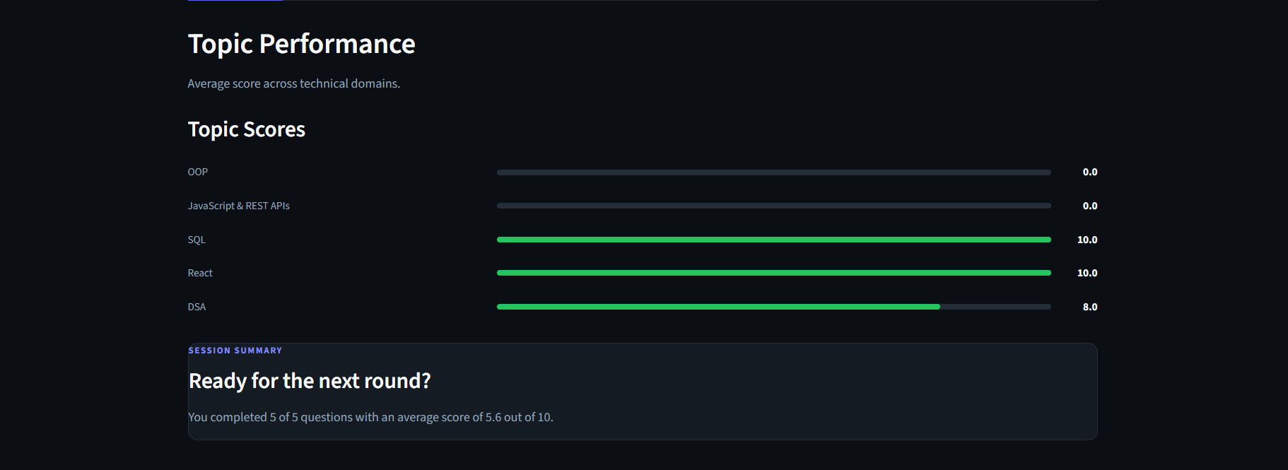
Key Features Demonstrated in this View:
- Circular Score Gauge: Color-coded visual metric gauge (84% overall performance).
- Competency & Difficulty Charts: Granular breakdown across topics (Python, Algorithms, System Design) and difficulty.
- Multi-Format Export Row: 3 download buttons for PDF Report (ReportLab), Markdown, and CSV details.
- Question Debrief Expander: Full review of prompt, candidate response, benchmark answer, and evaluator comments.

EXHIBIT-06: Progress Archive & Session History Tracking
Persistent historical session log tracking score trajectories over time.
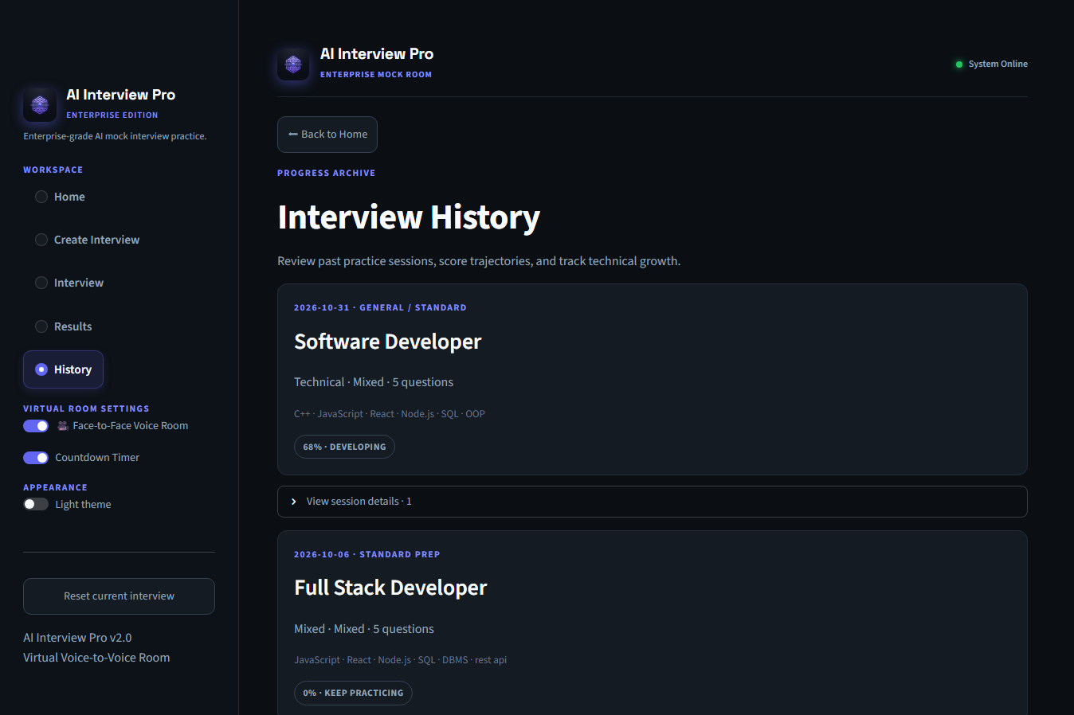
Key Features Demonstrated in this View:
- Local JSON Persistence: Saves all completed reports to data/interview_history.json.

